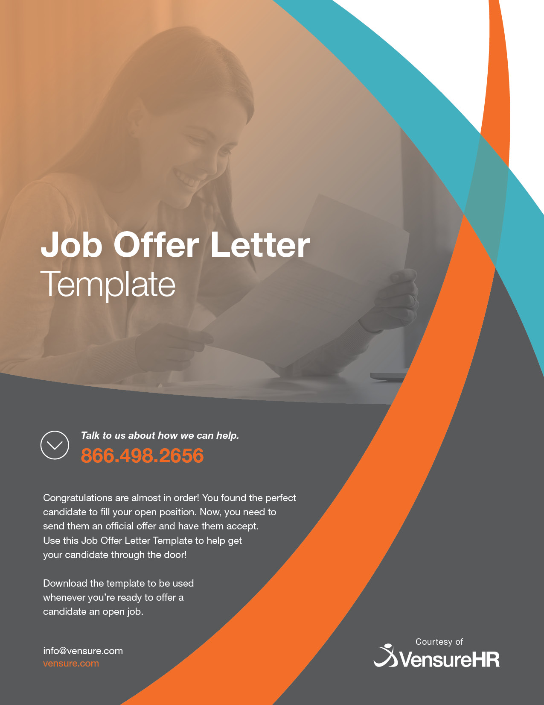

Date
Recipient First and Last Name
Recipient Address

Dear {Recipient First Name},

I am excited to offer you {Full time/Part-time/contract/internship} employment with {Company name} as the company’s {Position Title}. Your skills and impressive resume are an ideal fit for our {Department Title}.
As we previously discussed, your start date will be {Start Date}. Furthermore, your beginning salary will be {$$$} per {week/month/year/project} and is paid on a {weekly/bi-weekly/monthly} basis. Direct deposit is available at your request.
If you wish to opt-in, full medical coverage will be provided through {Company’s Name} benefits package. This package will be made available on {Effective Date}, this date is {Number of Days} from the start of your employment. {Company’s Name} also offers a generous time-off package—this includes {(paid) vacation, personal, and sick leave} {(unpaid) vacation, personal, and sick leave}. Time off accrues at the rate of {Number of Days} per {pay period, week, month, year} for your first year and is subject to increase as your tenure with the company does.
You will be eligible to opt into {Company’s Name} retirement plan {Number of Days} after your start date.
If you decide to accept our offer, please sign this offer letter and send it back at your earliest convenience. Additionally, please save a copy of this offer for your file.
Once we receive your signed and agreed acknowledgment, we will send you our benefit enrollment forms, employee handbook, and important information with regard to your onboarding.
Please contact me if you have any questions or concerns.
Congratulations on your job offer—we eagerly await your acceptance!

Sincerely,
Hiring Manager Name
Hiring Manager Title
Hiring Manager Contact
Company Name

I, {Recipient Name}, accept the position of {Position Title}.
Signature _________________________________________________ Date _________________

